# LECTURENOTES

## UNIT-I

|  |
| --- |
| Introduction – Wireless transmission – Frequencies for radio transmission – Signals – Antennas Multiplexing – Modulations – Spread spectrum, Cellular Wireless Networks, 4G -Introduction, features and challenges, Applications of 4G, 4G Network architecture. |

**Introduction - Wireless transmission**

There are two different kinds of mobility: **user mobility** and **device portability**. User mobility refers to a user who has access to the same or similar telecommunication services at different places, i.e., the user can be mobile, and the services will follow him or her.

With device portability, the communication device moves (with or without a user). Many mechanisms in the network and inside the device have to make sure that communication is still possible while the device is moving. A typical example for systems supporting device portability is the mobile phone system, where the system itself hands the device from one radio transmitter (also called a base station) to the next if the signal becomes too weak.

With regard to devices, the term wireless is used. This only describes the way of accessing a network or other communication partners, i.e., with out a wire. The wire is replaced by the transmission of electromagnetic waves through ‘the air’ (although wireless transmission does not need any medium).

A communication device can thus exhibit one of the following characteristics:

* **Fixed and wired**: This configuration describes the typical desktop computer in an office. Neither weight nor power consumption of the devices allow for mobile usage. The devices use fixed networks for performance reasons.
* **Mobile and wired**: Many of today’s laptops fall into this category; users carry the laptop from one hotel to the next, reconnecting to the company’s network via the telephone network and a modem.
* **Fixed and wireless**: This mode is used for installing networks, e.g., in historical buildings to avoid damage by installing wires, or at trade shows to ensure fast network setup. Another example is bridging the last mile to a customer by a new operator that has no wired infrastructure and does not want to lease lines from a competitor.
* **Mobile and wireless**: This is the most interesting case. No cable restricts the user, who can roam between different wireless networks. Most technologies discussed in this book deal with this type of device and the networks supporting them. Today’s most successful example for this category is GSM with more than 800 million users.

## 

## Applications

* 1. **Vehicles**

Today’s cars already comprise some, but tomorrow’s cars will comprise many wireless communication systems and mobility aware applications. Music, news, road conditions, weather reports, and other broadcast information are received via digital audio broadcasting (DAB) with1.5 Mbit/s. For personal communication, a universal mobile telecommunication system (UMTS)phone might be available offering voice and data connectivity with 384 Kbit/s. For remote areas, satellite communication can be used, while the current position of the car is determined via the global positioning system (GPS). Cars driving in the same area build a local ad-hoc network for the fast exchange of information in emergency situations or to help each other keep a safe distance. In case of an accident, not only will the airbag be triggered, but the police and ambulance service will be informed via an emergency call to a service provider. Cars with this technology are already available. In the future, cars will also inform other cars about accidents via head-hoc network to help them slowdown in time, even before a driver can recognize an accident. Buses, trucks, and trains are already transmitting maintenance and logistic information to their home base, which helps to improve organization (fleet management), and saves time and money.

## Emergencies

Just imagine the possibilities of an ambulance with a high-quality wireless connection to a hospital. Vital information about injured persons can be sent to the hospital from the scene of the accident. All the necessary steps for this particular type of accident can be prepared and specialists can be consulted for an early diagnosis. Wireless networks are the only means of communication inthecaseofnaturaldisasterssuchashurricanesorearthquakes.Intheworstcases, only decentralized, wireless ad-hoc networks survive. The breakdown of all cabling not only implies the failure of the standard wired telephone system, but also the crash of all mobile phone systems requiring base stations!

## Business

A travelling salesman today needs instant access to the company’s database: to ensure that files on his or her laptop reflect the current situation, to enable the company to keep track of all activities of their travelling employees, to keep databases consistent etc. With wireless access, the laptop can be turned into a true mobile office, but efficient and powerful synchronization mechanisms are needed to ensure data consistency. At home, the laptop connects via a WLAN or LAN and DSL to the Internet. Leaving home requires a handover to another technology, e.g., to an enhanced version of GSM, as soon as the WLAN coverage ends. Due to interference and other factors discussed in chapter 2, data rates drop while cruising at higher speed. Gas stations may offer WLAN hot spots as well as gas. Trains already offer support for wireless connectivity. Several more handovers to different technologies might be necessary before reaching the office. No matter when and where, mobile communications should always offer as good connectivity as possible to the internet, the company’s intranet, or the telephone network.

## Replacement of wired networks

In some cases, wireless networks can also be used to replace wired networks, e.g., remote sensors, for tradeshows, or in historic buildings. Due to economic reasons, it is often impossible to wire remote sensors for weather forecasts, earth quake detection, or to provide environmental information. Wireless connections, e.g., via satellite, can help in this situation. Tradeshows need a highly dynamic infrastructure, but cabling takes a long time and frequently proves to be too inflexible. Many computer fairs use WLANs as a replacement for cabling. Other cases for wireless networks are computers, sensors, or information displays in historical buildings, where excess cabling may destroy valuable walls or floors. Wireless access points in a corner of the room can represent solution.

## A simplified reference model

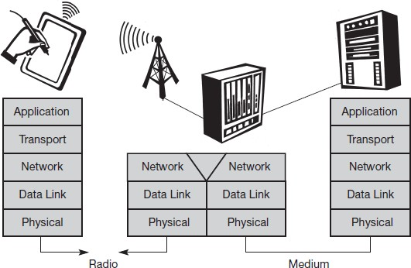

* **Physical layer**: This is the lowest layer in a communication system and is responsible for the conversion of a stream of bits into signals that can be transmitted on the sender side. The physical layer of the receiver then transforms the signals back into a bit stream. For wireless communication, the physical layer is responsible for frequency selection, generation of the carrier frequency, signal detection (although heavy interference may disturb the signal), modulation of data onto a carrier frequency and (depending on the transmission scheme) encryption.
* **Data link layer**: The main tasks of this layer include accessing the medium, multiplexing of different data streams, correction of transmission errors, and synchronization (i.e., detection of a data frame). Altogether, the data link layer is responsible for a reliable point-to point connection between two devices or apoint-to-multipointconnectionbetweenonesenderandseveralreceivers.
* **Network layer**: This third layer is responsible for routing packets through a network or establishing a connection between two entities over many other intermediate systems. Important to pics are addressing, routing, device location, and handover between different networks.
* **Transport layer**: This layer is used in the reference model to establish an end-to-end connection. Topics like quality of service, flow and congestion control are relevant, especially if the transport protocols known from the Internet, TCP and UDP, are to be used over a wireless link.
* **Application layer**: Finally, the applications (complemented by additional layers that can support applications) are situated on top of all transmission oriented layers. Topics of interest in this context are service location, support for multimedia applications, adaptive applications that can handle the large variations in transmission characteristics, and wireless access to the World Wide Web using a portable device. Very demanding applications are video ( high data rate) and interactive gaming (low jitter, low latency).

## Frequencies for radio transmission

Radio transmission can take place using many different frequency bands. Each frequency band exhibits certain advantages and disadvantages The figure shows frequencies starting at 300 Hz and going up to over 300 THz. Directly coupled to the frequency is the wavelength λ via the equation:

λ = c/f, where c ≅ 3·108 m/s (the speed of light in vacuum) and f the frequency.

For traditional wired networks, frequencies of up to several hundred kHz are used for distances up to some km with twisted pair copper wires, while frequencies of several hundred MHz are used with coaxial cable (new coding schemes work with several hundred MHz even with twisted pair copper wires over distances of some 100 m). Fiber optics are used for frequency ranges of several hundred THz, but here one typically refers to the wavelength which is, e.g., 1500 nm, 1350 nm etc. (infra-red).

Radio transmission starts at several kHz, the very low frequency (VLF) range. These are very long waves. Waves in the low frequency (LF) range are used by submarines, because they can penetrate water and can follow the earth’s surface.

Some radio stations still use these frequencies, e.g., between 148.5 kHz and 283.5 kHz in Germany. The medium frequency (MF) and high frequency (HF) ranges are typical for transmission of hundreds of radio stations either as amplitude modulation (AM) between 520 kHz and 1605.5 kHz, as short wave (SW) between 5.9 MHz and 26.1 MHz, or as frequency modulation (FM) between 87.5 MHz and 108 MHz.

The frequencies limiting these ranges are typically fixed by national regulation and, vary from country to country.

Short waves are typically used for (amateur) radio transmission around the world, enabled by reflection at the ionosphere. Transmit power is up to 500 kW – which is quite high compared to the 1 W of a mobile phone.

Digital audio broadcasting (DAB) takes place as well (223–230 MHz and 1452–1472 MHz) and digital TV is planned or currently being installed (470– 862 MHz), reusing some of the old frequencies for analog TV.

UHF is also used for mobile phones with analog technology (450–465 MHz), the digital GSM (890–960 MHz, 1710–1880 MHz), digital cordless telephones following the DECT standard (1880–1900 MHz), 3G cellular systems following the UMTS standard (1900–1980 MHz, 2020–2025 MHz, 2110–2190 MHz) and many more. VHF and especially UHF allow for small antennas and relatively reliable connections for mobile telephony. Super high frequencies (SHF) are typically used for directed microwave links (approx. 2–40 GHz) and fixed satellite services in the C-band (4 and 6 GHz), Ku-band (11 and 14 GHz), or Ka-band (19 and 29 GHz). Some systems are planned in the extremely high frequency (EHF) range which comes close to infra-red. All radio frequencies are regulated to avoid interference, e.g., the German regulation covers 9 kHz–275 GHz. The next step into higher frequencies involves optical transmission, which is not only used for fiber optical links but also for wireless communications. Infra-red (IR) transmission is used for directed links, e.g., to connect different buildings via laser links. The most widespread IR technology, infra-red data association (IrDA), uses wavelengths of approximately 850–900 nm to connect laptops, PDAs etc. Finally, visible light has been used for wireless transmission for thousands of years. While light is not very reliable due to interference, but it is nevertheless useful due to built-in human receivers.

**Data and Signals**

To be transmitted, data must be transformed to electromagnetic signals

Both data and the signals that represent them can be either analog or digital in form.

# Analog and Digital Data

Data can be analog or digital. The term analog data refers to information that is continuous; digital data refers to information that has discrete states

Analog data, such as the sounds made by a human voice, take on continuous values. When someone speaks, an analog wave is created in the air. This can be captured by a microphone and converted to an analog signal or sampled and converted to a digital signal. Digital data take on discrete values. For example, data are stored in computer memory in the form of Os and 1s. They can be converted to a digital signal or modulated into an analog signal for transmission across a medium.

Signals can be analog or digital. Analog signals can have an infinite number of values in a range; digital signals can have only a limited number of values

# Antennas

As the name wireless already indicates, this communication mode involves ‘getting rid’ of wires and transmitting signals through space without guidance. We do not need any ‘medium’ (such as ether) for the transport of electromagnetic waves.

# Antennas couple electromagnetic energy to and from space to and from a wire or coaxial cable (or any other appropriate conductor). A theoretical reference antenna is the isotropic radiator, a point in space radiating equal power in all directions, i.e., all points with equal power are located on a sphere with the antenna as its center. The radiation pattern is symmetric in all directions two dimensional

**Real antennas**

Exhibit directive effects, i.e., the intensity of radiation are not the same in all directions from the antenna. The simplest real antenna is a thin, center-fed dipole, also called Hertzian dipole; the dipole consists of two collinear conductors of equal length, separated by a small feeding gap. The length of the dipole is not arbitrary, but, for example, half the wavelength λ of the signal to transmit results in a very efficient radiation of the energy. If mounted on the roof of a car, the length of λ/4 is efficient. This is also known as Marconi antenna. A λ/2 dipole has a uniform or Omni-directional radiation pattern in one plane.

## Signal propagation

Like wired networks, wireless communication networks also have senders and receivers of signals. However, in connection with signal propagation, these two networks exhibit considerable differences. In wireless networks, the signal has no wire to determine the direction of propagation, whereas signals in wired networks only travel along the wire (which can be twisted pair copper wires, a coax cable, but also a fiber etc.). As long as the wire is not interrupted or damaged, it typically exhibits the same characteristics at each point. One can precisely determine the behavior of a signal travelling along this wire, e.g., received power depending on the length. For wireless transmission, this predictable behavior is only valid in a vacuum, i.e., without matter between the sender and the receiver.

**Transmission range**: Within a certain radius of the sender transmission is possible, i.e., a receiver receives the signals with an error rate low enough to be able to communicate and can also act as sender.

* Detection range: Within a second radius, detection of the transmission is possible, i.e., the transmitted power is large enough to differ from background noise. However, the error rate is too high to establish communication.
* Interference range: Within a third even larger radius, the sender may interfere with other transmission by adding to the background noise. A receiver will not be able to detect the signals, but the signals may disturb other signals.

**MULTIPLEXING**

Bandwidth utilization is the wise use of available bandwidth to achieve specific goals. Efficiency can be achieved by multiplexing; privacy and ant jamming can be achieved by spreading.

Multiplexing is the set of techniques that allows the simultaneous transmission of multiple signals across a single data link. As data and telecommunications use increases, so does traffic. We can accommodate this increase by continuing to add individual links each time a new channel is needed; or we can install higher-bandwidth links and use each to carry multiple signals.

There are three basic multiplexing techniques: frequency-division multiplexing, wavelength- division multiplexing, and time-division multiplexing. The first two are techniques designed for analog signals, the third, for digital signals.

FDM is an analog multiplexing technique that combines analog signals.

WDM is an analog multiplexing technique to combine optical signals.

TDM is a digital multiplexing technique for combining several low-rate channels into one high-rate one.

In synchronous TDM, the data rate of the link is *n* times faster, and the unit duration is *n* times shorter.

## Space division multiplexing

## For wireless communication, multiplexing can be carried out in four dimensions: space, time, frequency, and code. In this field, the task of multiplexing is to assign space, time, frequency, and code to each communication channel with a minimum of interference and a maximum of medium utilization. The term communication channel here only refers to an association of sender(s) and receiver(s) who want to exchange data six channels ki and introduces a three dimensional coordinate system.

This system shows the dimensions of code c, time t and frequency f. For this first type of multiplexing, space division multiplexing (SDM) The channels k1 to k3 can be mapped onto the three ‘spaces’ s1 to s3 which clearly separate the channels and prevent the interferenceranges from overlapping. The space between the interference ranges is sometimes called guard space. Such a guard space is needed in all four multiplexing schemes presented.

## Frequency division multiplexing

Frequency division multiplexing (FDM) describes schemes to subdivide the frequency dimension into several non-overlapping frequency bands

## Each channel ki is now allotted its own frequency band as indicated. Senders using a certain frequency band can use this band continuously. Again, guard spaces are needed to avoid frequency band overlapping (also called adjacent channel interference). This scheme is used for radio stations within the same region, where each radio station has its own frequency.

## This very simple multiplexing scheme does not need complex coordination between sender and receiver: the receiver only has to tune in to the specific sender.

## Time division multiplexing

## A more flexible multiplexing scheme for typical mobile communications is time division multiplexing (TDM). Here a channel is given the whole bandwidth for a certain amount of time, i.e., all senders use the same frequency but at different points in time .Again, guard spaces, which now represent time gaps, have to separate the different periods when the senders use the medium. In our highway example, this would refer to the gap between two cars. If two transmissions overlap in time, this is called co-channel interference. (In the highway example, interference between two cars results in an accident.) To avoid this type of interference, precise synchronization between different senders is necessary.

This is clearly a disadvantage, as all senders need precise clocks or, alternatively, a way has to be found to distribute a synchronization signal to all senders. For a receiver tuning in to a sender this does not just involve adjusting the frequency, but involves listening at exactly the right point in time. However, this scheme is quite flexible as one can assign more sending time to senders with a heavy load and less to those with a light load. frequency and time division multiplexing can be combined, i.e., a channel can use a certain frequency band for a certain amount of time Now guard spaces are needed both in the time and in the frequency dimension. This scheme is more robust against frequency selective interference, i.e., interference in a certain small frequency band. A channel may use this band only for a short period of time. Additionally, this scheme provides some (weak) protection against tapping, as in this case the sequence of frequencies a sender uses has to be known to listen in to a channel. The mobile phone standard GSM uses this combination of frequency and time division multiplexing for transmission between a mobile phone and a so-called base station.

## Code division multiplexing

## While SDM and FDM are well known from the early days of radio transmission and TDM is used in connection with many applications, code division multiplexing (CDM) is a relatively new scheme in commercial communication systems. First used in military applications due to its inherent security features (together with spread spectrum techniques, it now features in many civil wireless transmission scenarios thanks to the availability of cheap processing power channels use the same frequency at the same time for transmission.

Separation is now achieved by assigning each channel its own ‘code’, guard spaces are realized by using codes with the necessary ‘distance’ in code space, e.g., orthogonal codes. The main advantage of CDM for wireless transmission is that it gives good protection against interference and tapping. Different codes have to be assigned, but code space is huge compared to the frequency space. Assigning individual codes to each sender does not usually cause problems.

The main disadvantage of this scheme is the relatively high complexity of the receiver. A receiver has to know the code and must separate the channel with user data from the background noise composed of other signals and environmental noise. Additionally, a receiver must be precisely synchronized with the transmitter to apply the decoding correctly. The voice example also gives a hint to another problem of CDM receivers.

All signals should reach a receiver with almost equal strength; otherwise some signals could drain others. If some people close to a receiver talk very loudly the language does not matter. The receiver cannot listen to any other person. To apply CDM, precise power control is required.

**SPREAD SPECTRUM**

In spread spectrum, we also combine signals from different sources to fit into a larger bandwidth, but our goals are somewhat different. Spread spectrum is designed to be used in wireless applications (LANs and WANs). In these types of applications, we have some concerns that outweigh bandwidth efficiency. In wireless applications, all stations use air (or a vacuum) as the medium for communication spread spectrum techniques add redundancy; they spread the original spectrum needed for each station.

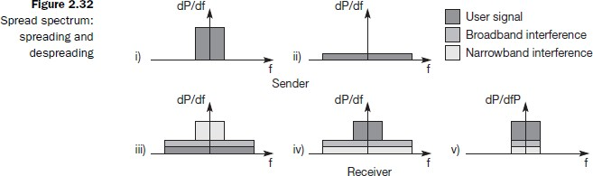

There are two techniques to spread the bandwidth: frequency hopping spread spectrum (FHSS) and direct sequence spread spectrum (DSSS).

## Frequency Hopping Spread Spectrum (FHSS)

The frequency hopping spread spectrum (FHSS) technique uses *M* different carrier frequencies that are modulated by the source signal. At one moment, the signal modulates one carrier frequency; at the next moment, the signal modulates another carrier frequency. Although the modulation is done using one carrier frequency at a time, *M* frequencies are used in the long run.

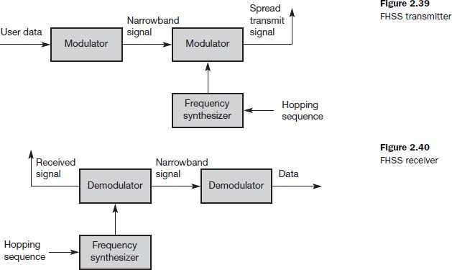

A pseudorandom code generator, called pseudorandom noise (PN), creates a k-bit pattern for every hopping period *Th*

*•* The frequency table uses the pattern to find the frequency to be used for this hopping period and passes it to the frequency synthesizer. The frequency synthesizer creates a carrier signal of that frequency, and the source signal modulates the carrier signal.

## Direct Sequence Spread Spectrum

The direct sequence spread spectrum (nSSS) technique also expands the bandwidth of the original signal, but the process is different. In DSSS, we replace each data bit with 11 bits using a spreading code. In other words, each bit is assigned a code of 11 bits, called chips, where the chip rate is 11 times that of the data bit. Spreading code is 11 chips having the pattern 10110111000 (in this case). If the original signal rate is *N,* the rate of the spread signal is *lIN.*

Bandwidth for signal can provide privacy if the intruder does not know the code. It can also provide immunity against interference if each station uses a different code.

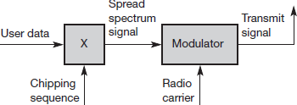

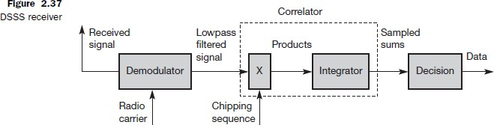

## Cellular systems

Cellular systems for mobile communications implement SDM. Each transmitter, typically called a base station, covers a certain area, a cell. Cell radii can vary from tens of meters in buildings, and hundreds of meters in cities, up to tens of kilometers in the countryside. The shape of cells are never perfect circles or hexagons but depend on the environment (buildings, mountains, valleys etc.), on weather conditions, and sometimes even on system load. Typical systems using this approach are mobile telecommunication systems.

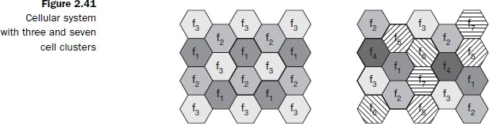

## Advantages of cellular systems with small cells are the following:

**Higher capacity**: Implementing SDM allows frequency reuse. If one transmitter is far away from another, i.e., outside the interference range, it can reuse the same frequencies. As most mobile phone systems assign frequencies to certain users (or certain hopping patterns), this frequency is blocked for other users. But frequencies are a scarce resource and, the number of concurrent users per cell is very limited. Huge cells do not allow for more users. On the contrary, they are limited to less possible users per km2. This is also the reason for using very small cells in cities where many more people use mobile phones.

**Less transmission power**: While power aspects are not a big problem for base stations, they are indeed problematic for mobile stations. A receiver far away from a base station would need much more transmit power than the current few Watts. But energy is a serious problem for mobile handheld devices.

**Local interference only**: Having long distances between sender and receiver results in even more interference problems. With small cells, mobile stations and base stations only have to deal with ‘local’ interference.

**Robustness**: Cellular systems are decentralized and so, more robust against the failure of single components. If one antenna fails, this only influences communication within a small area.

# Introduction To 4G

# The First generation wireless mobile communication systems were introduced in early eighties and second generations’ systems in the late 1980s was intended primarily for transmission of voice. The initial systems used analog frequency modulation whereas the second as well as the subsequent mobile systems use digital communication techniques with time division multiplexing (TDM), frequency division multiplexing (FDM) or the code division multiple access (CDMA). The third generation wireless systems which are just getting introduced in the world markets offer considerably higher data rates, and allow significant improvements over the 2G systems. The 3G Wireless systems were proposed to provide voice and paging services to provide interactive multimedia including teleconferencing and internet access and variety of other services. However, these systems offer wide area network (WAN) coverage of 384 kbps peak rate and limited coverage for 2 Mbps. Hence providing broadband services would be one of the major goals of the 4G Wireless systems.

# 

## Categories

4G comes in two main categories –

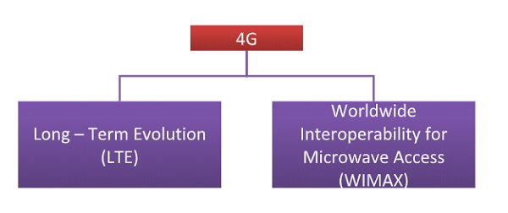

* **Long – Term Evolution (LTE)−** Long – term evolution or LTE is an extension of the 3G technology. It is a standard for high-speed mobile communication, based upon GSM/EDGE and UMTS/HSPA technologies. The peak data rate for download is 100 Mbps and upload is 50 Mbps. The LTE Advanced meets the specifications of IMT-Advanced standard for 4G technology. Its peak data rates are 1000 Mbps for downlink and 500 Mbps for uplink.
* **Worldwide Interoperability for Microwave Access (WIMAX)−** WiMAX is a mobile wireless broadband access (MWBA) standard is sometimes branded 4G. It offers peak data rates of 128 Mbps for downlink and 56 Mbps for uplink over 20 MHz wide channels. The latest version of WIMAX is not compatible to the earlier versions and instead is compatible with LTE.

# Features of 4G Wireless Systems

# The following are some possible features of the 4G systems: 1. Support interactive multimedia, voice, video, wireless internet and other broadband services. 2. High speed, high capacity and low cost per bit. 3. Global mobility, service portability, scalable mobile networks. 4. Seamless switching, variety of services based on Quality of Service (QoS) requirements 5. Better scheduling and call admission control techniques. 6. Ad hoc networks and multi-hop networks

# Some additional features

# It provides an all IP packet switched network for transmission of voice, data, signals and multimedia.

1. It aims to provide high quality uninterrupted services to any location at any time.
2. As laid down in IMT-Advanced specifications, 4G networks should have peak data rates of 100Mbps for highly mobile stations like train, car etc., and 1Gbps for low mobility stations like residence etc.
3. It also lays down that 4G networks should make it possible for 1 Gbps downlink over less than 67 MHz bandwidth.
4. They provide have smooth handoffs across heterogeneous network areas.

# 3G Vs 4G

       The following table shows comparisons between some key parameters of 3G Vs possible 4G systems.

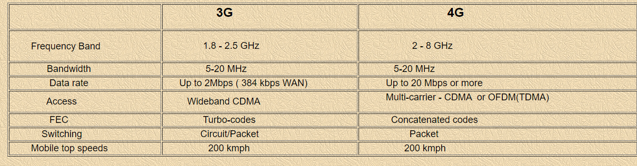

## Some new challenges in 4G

1. Multi-access interface, timing and recovery.  
2. Higher frequency reuse leads to smaller cells that may cause intra-cell interference or higher noise figures due to reduced power levels.  
3. The Digital to analog conversions at high data rates, multiuser detection and estimation (at base stations), smart antennas and complex error control techniques as well dynamic routing will need sophisticated signal processing.  
4. Issues in the interface with the ad hoc networks should be sorted out. 4G systems are expected to interact with other networks like the Bluetooth, hiperlan, IEEE802.11b, etc.  
5. Voice over multi-hop networks is likely to be an interesting problem because of the strict delay requirements of voice.  
6. Security will be an important issue.  
7. A new IP protocol might be needed because of the variable QoS services and the network should do “better than best " effort.  
8. Networking protocols that adapt dynamically to the changing channel conditions.  
9. Seamless roaming and seamless transfer of services.

## Application Areas

* + Advanced mobile web access
  + IP telephony
  + High-resolution high-speed gaming services
  + Streamed multimedia and data
  + High-definition mobile TV
  + Video conferencing
  + 3D television

## Advantages of 4G

The advantages of 4G are as follows −

* Quicker connection.
* In-building coverage has been improved.
* Autonomous network.
* Scalable and software independent.

## Challenges of 4G

The challenges that 4G faced during implementation are as follows −

* Multimode User Terminals.
* Heterogeneity of 4G Network.
* Right Selection of wireless System.
* When in roaming the frequency is incompatible.
* Quality of Service (QoS) Support and Network Infrastructure.

# LTE Architecture(4G) Concepts

The Long Term Evolution Standard (LTE) is a wireless communications, high-speed data standard for mobile phones and data terminals. Its basis stands in the GSM/EDGE and UMTS/HSPA network technologies, with changes in terms of an increased capacity and higher speed by simplifying the core network and using a different radio interface.

